1. Jenkins login page

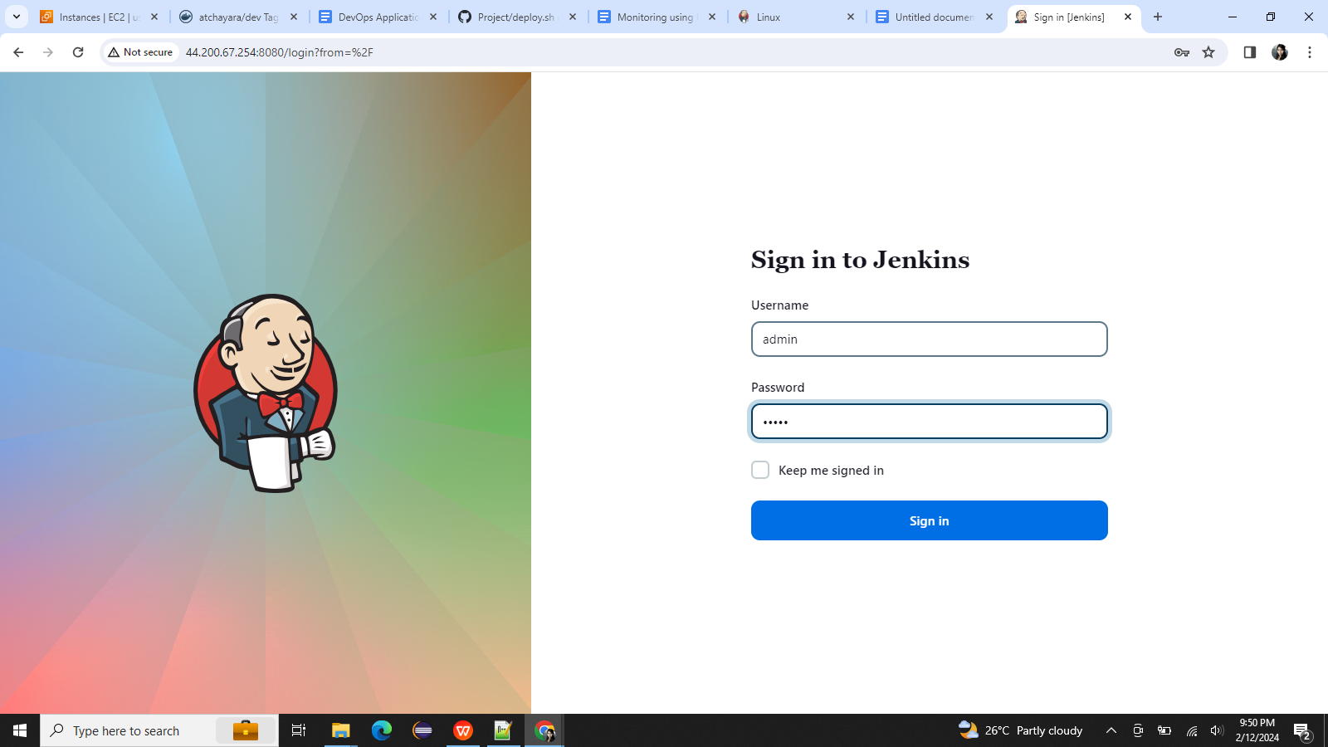

1. Dockerhub credentials setup

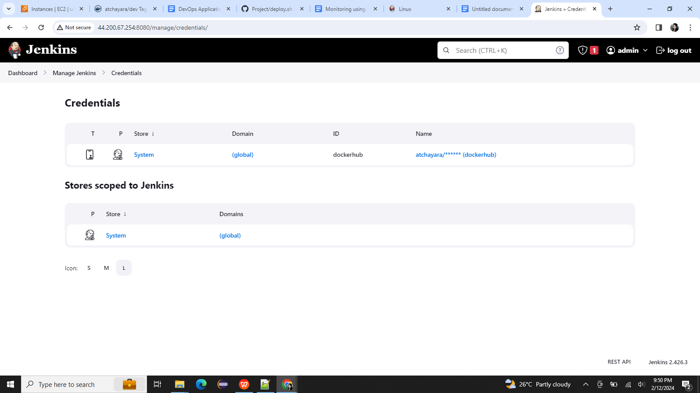

1. Environmental variable setup

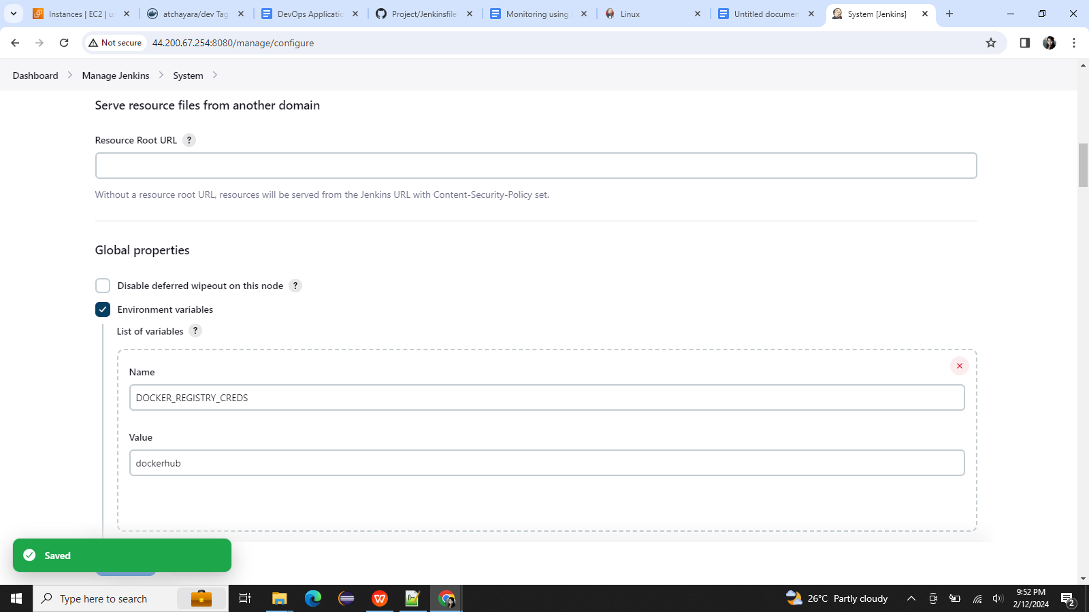

1. Jenkin pipeline configuration

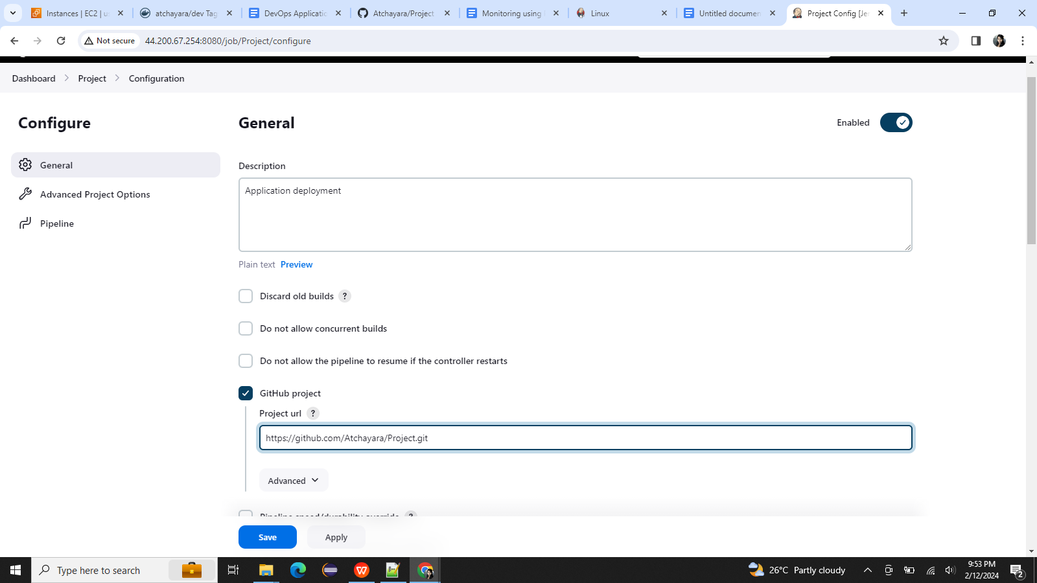

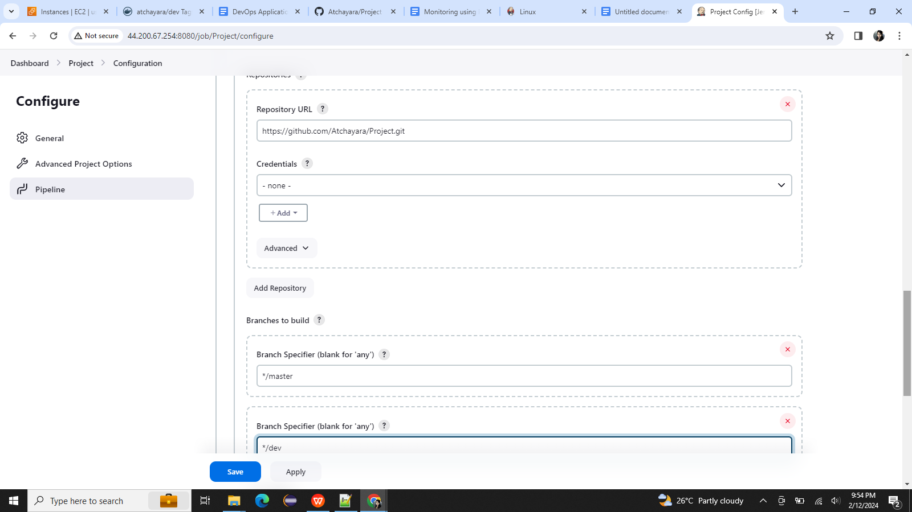

1. Code committed to dev branch

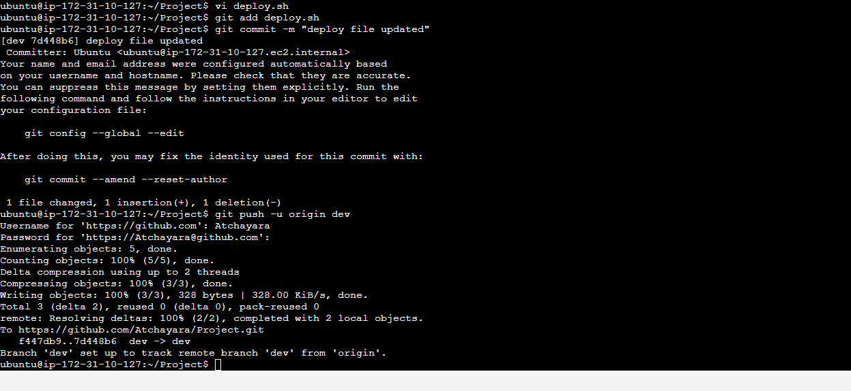

1. Auto deployment when code committed to dev – Succeeded

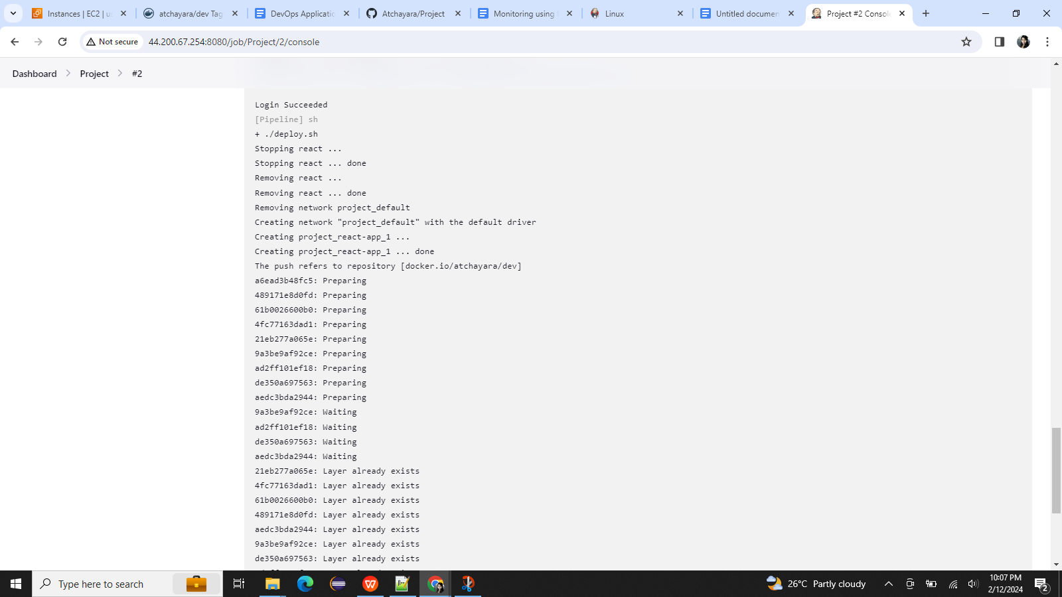

Docker images

Docker image name : reactapp

1. Docker dev repo

Docker image tagged as atchayara/dev

Docker dev repo – public

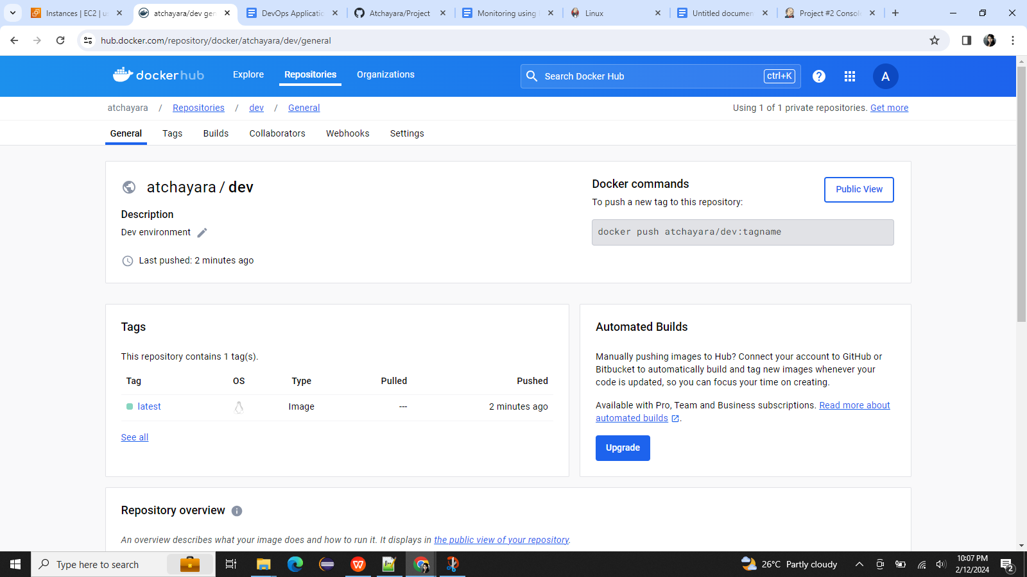

1. Code merged to master branch

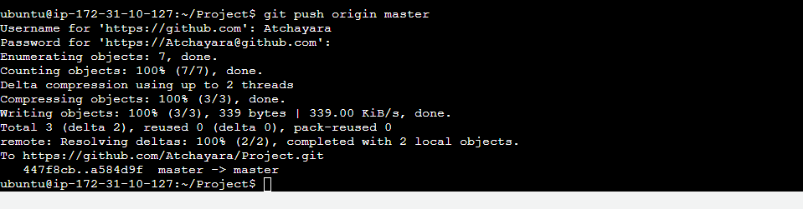

1. Auto deployment when code committed to master– Succeeded

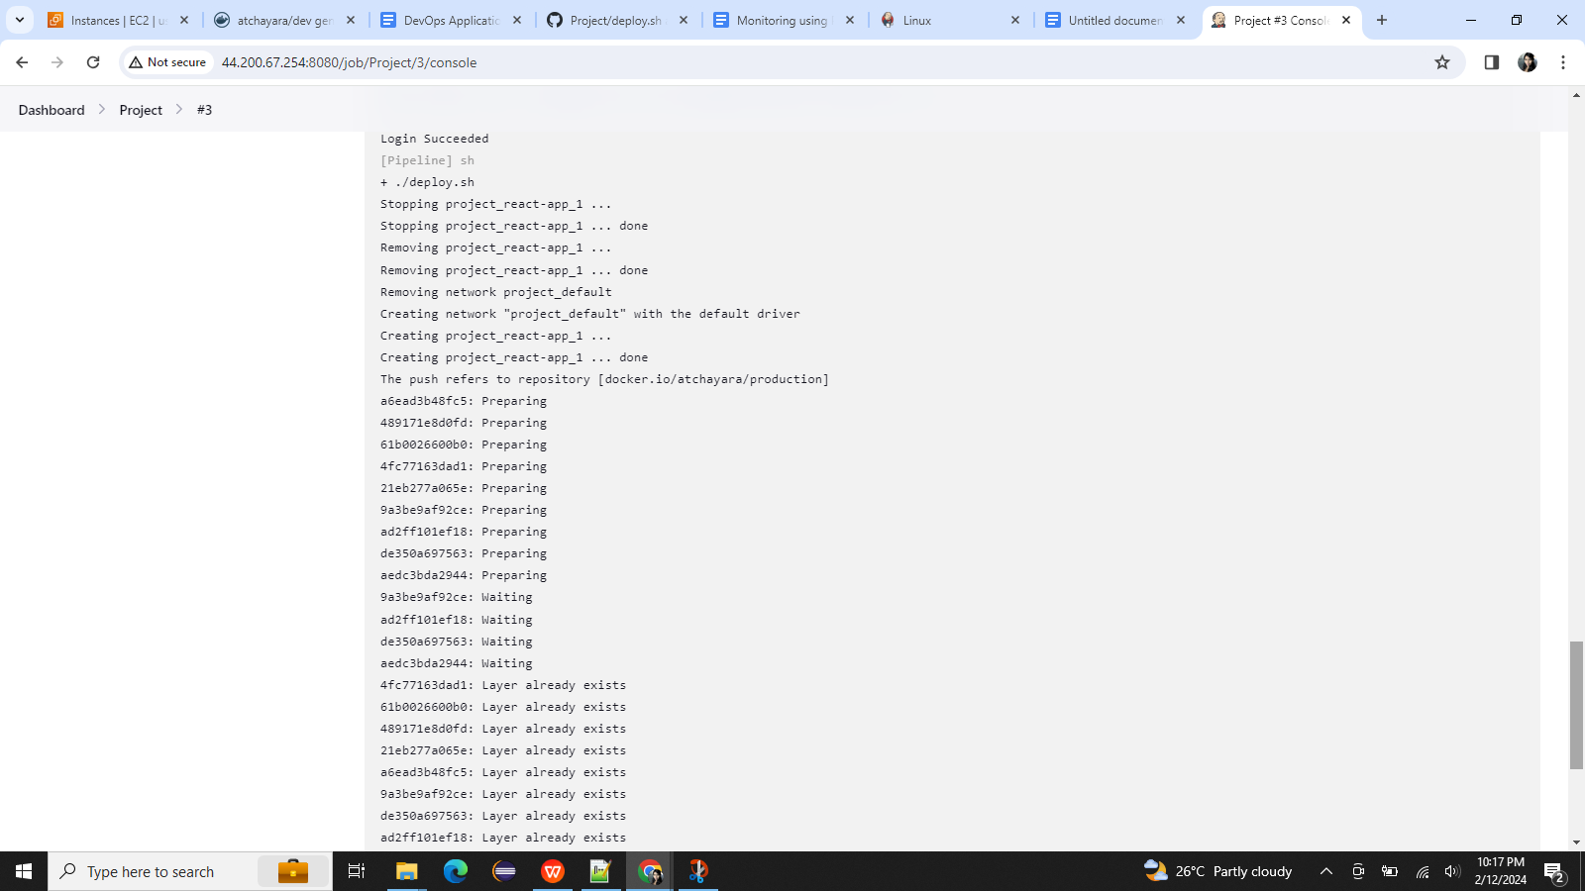

1. Dockerhub repo –production

Docker image tagged as atchayara/production

Production docker repo – Private

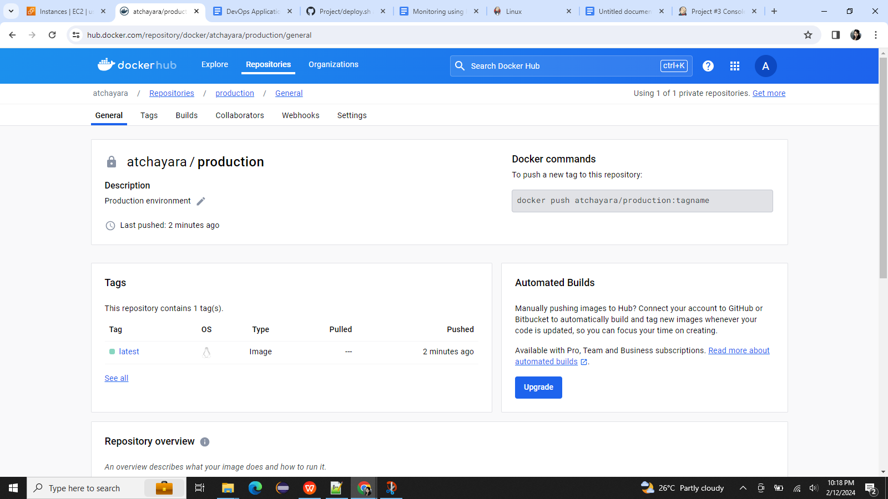

1. Deploy Application in EC2

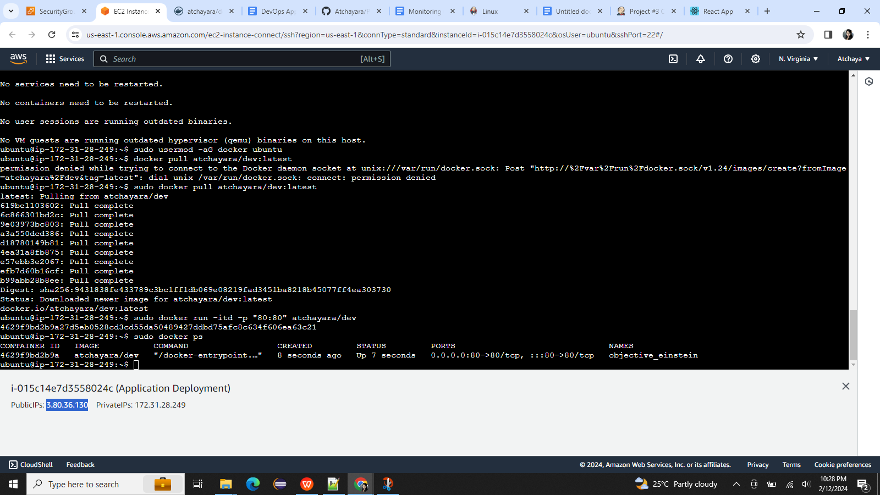

1. Security config of EC2 on which Application deployed

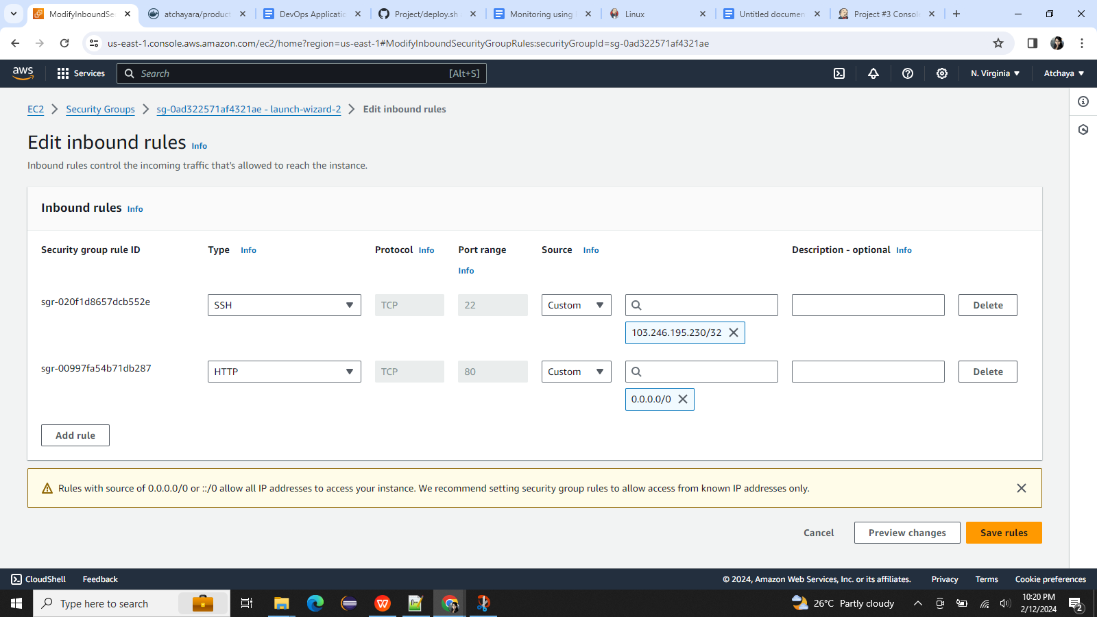

1. Deployed site

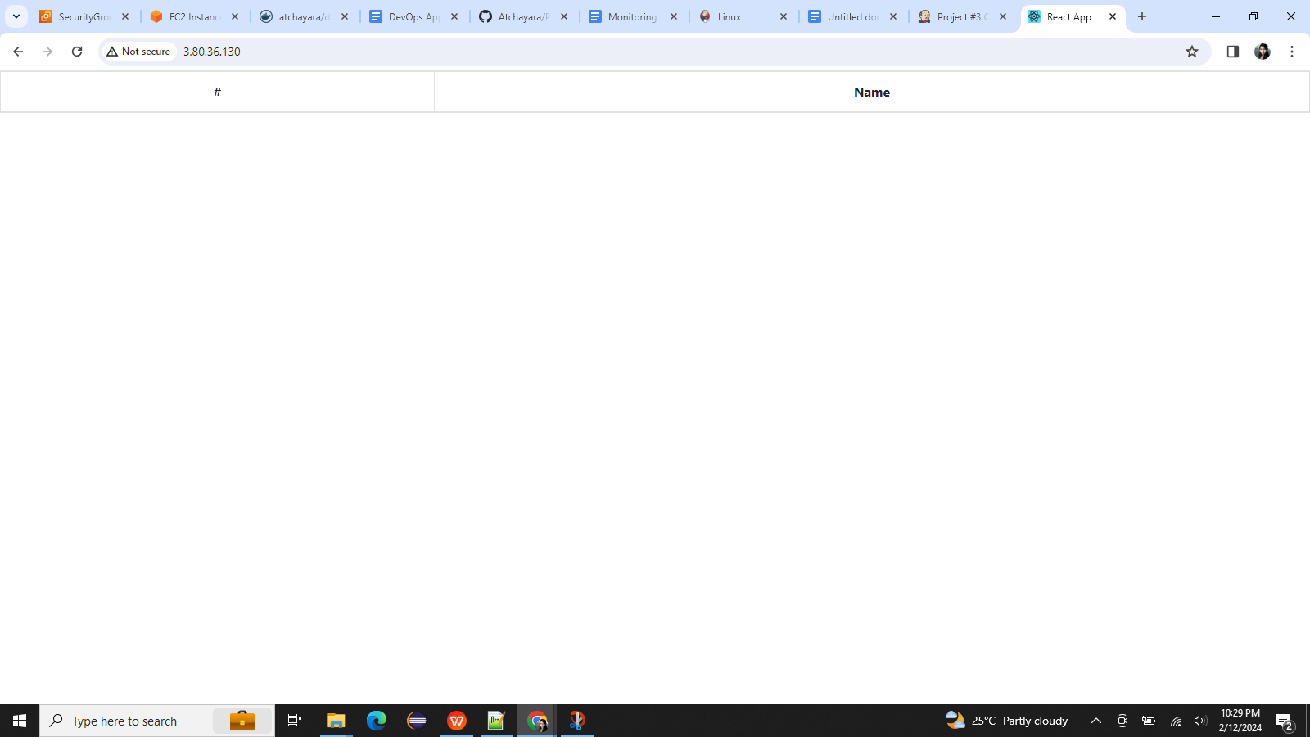

1. Monitoring health check status

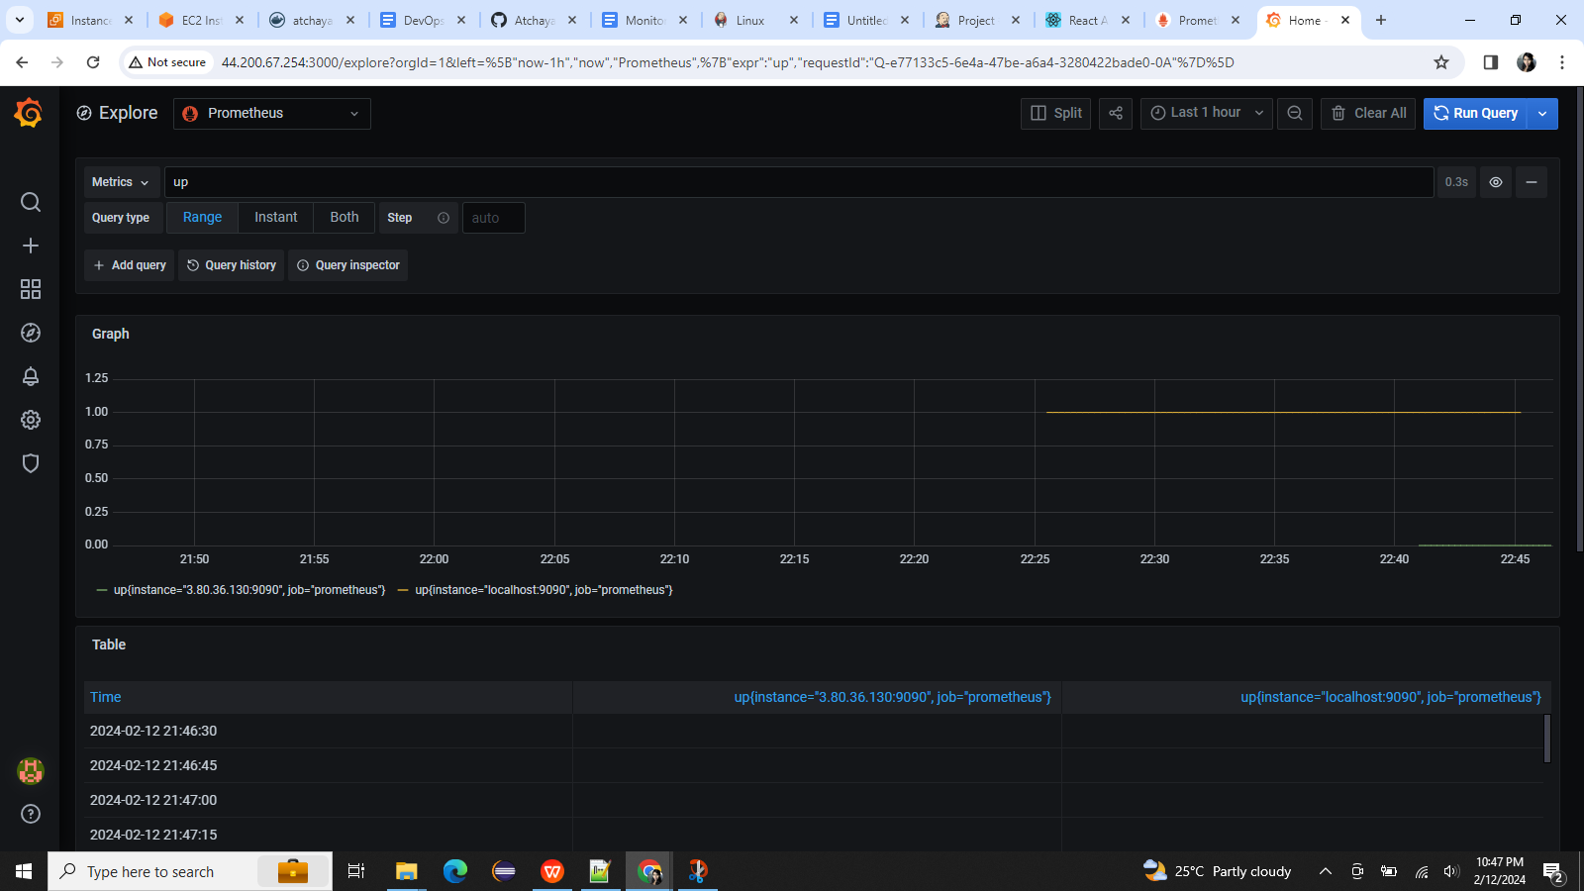

Different dashboard

